**Meeting Minutes**

Monday 15th March 1:30PM

Attendees:

Brendan Ho

Kahsheng Lee

Samart Khandelwal

Yifei Yu

Bing Xu

Giovanna Su

Absentees:

-

Agenda: Discussing interview questions

Motions

Users of the system: Students??

Roles

* Providing our current understanding - Kah, Brendan
* Question asking - Yifei, Samarth
* Note taking - Bing, Giovanna - setup a google docs

Interview objectives:

1. Be able to describe project background (motivation)
2. Problem
3. Scope of the solution

Current understanding:

* Motivation: Canvas LMS exists, but client wants a dashboard for how accessing, interacting and performing
* Developing a dashboard on canvas
* Analytics and core functionality
* Only users: students?

Interview Conducting:

* State current understanding of project
* Reconcile differences
* Ask questions
  + How much of H5P do they prefer us to use? preferences for tools?
  + What does self reflecting include?
  + How is that going to reflect in the analytics?
  + What performance metrics do we gather from the student?
  + How do we process it?
  + What is the output?
  + Are we just doing the UI?
  + Does the client have any preferences to how the students will interact with the dashboard?
  + How much customizability will the dashboard require?
  + What do we need to do, and what do we not need to do? (scope)
* Ask if he could provide us with scenarios for each potential user
* Take notes

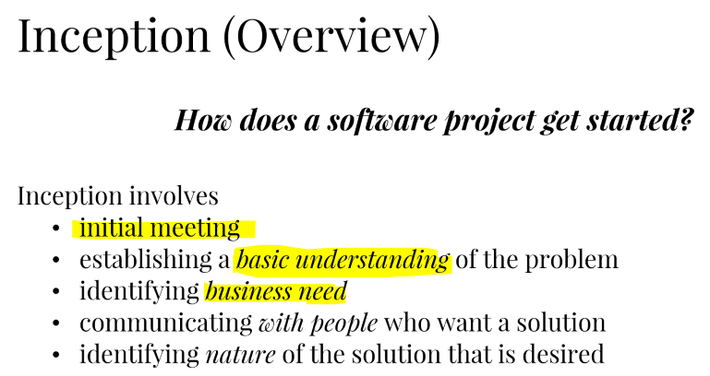

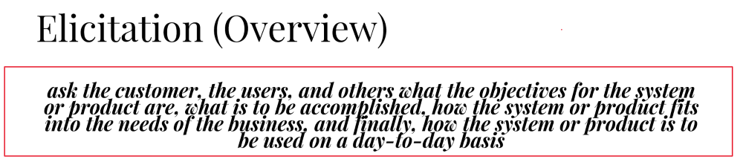

Next meeting date and time

Wednesday 10

Meeting Adjournment

2:00 PM